**Practical - 1 & 2**

**1). Problem Definition:** Initiate the “Project Title” by defining scope, key pages (min. 10), and layout with HTML skeletons.

**2). Problem Definition:** Design a fully responsive layout for the portal home, about, and registration pages using CSS and Flexbox/Grid.

|  |
| --- |
| **External CSS CODE :** |

**CODE(styles.css):**

/* === Global Styles === */

* {

  margin: 0;

  padding: 0;

  box-sizing: border-box;

  font-family: 'Segoe UI', Tahoma, Geneva, Verdana, sans-serif;

}

body {

  background-color: #ffffff;

  color: #333;

  line-height: 1.6;

}

h2, h3 {

  color: #003366;

}

/* === Announcement Bar === */

.announcement-bar {

  background-color: #003366;

  color: white;

  padding: 10px;

  text-align: center;

  font-weight: bold;

}

/* === Navbar === */

.navbar {

  background-color: #ffffff;

  padding: 15px 30px;

  display: flex;

  justify-content: space-between;

  align-items: center;

  box-shadow: 0 2px 5px rgba(0, 0, 0, 0.1);

}

.logo img {

  height: 50px;

}

.nav-links {

  list-style: none;

  display: flex;

  gap: 15px;

}

.nav-links li a {

  text-decoration: none;

  color: #003366;

  font-weight: 500;

  padding: 8px 12px;

  transition: background 0.3s, color 0.3s;

}

.nav-links li a:hover {

  background-color: #003366;

  color: white;

  border-radius: 5px;

}

/* === Hero Image === */

.hero-image {

  width: 100%;

  display: block;

  object-fit: cover;

}

/* === Faculty Buttons Grid === */

.faculty-section {

  padding: 40px 30px;

  text-align: center;

}

.faculty-buttons {

  display: grid;

  grid-template-columns: repeat(auto-fit, minmax(220px, 1fr));

  gap: 20px;

  margin-top: 30px;

}

.faculty-buttons button {

  padding: 15px 20px;

  background-color: #003366;

  color: white;

  border: none;

  border-radius: 8px;

  font-size: 1rem;

  font-weight: 500;

  cursor: pointer;

  transition: 0.3s ease;

}

.faculty-buttons button:hover {

  background-color: #002244;

  transform: translateY(-3px);

  box-shadow: 0 4px 10px rgba(0,0,0,0.1);

}

/* === Forms === */

.form-container {

  max-width: 600px;

  margin: auto;

  display: flex;

  flex-direction: column;

  gap: 15px;

  background-color: #ffffff;

  padding: 30px;

  border-radius: 10px;

  box-shadow: 0 0 10px rgba(0,0,0,0.1);

}

.form-container input,

.form-container select,

.form-container button {

  padding: 10px;

  font-size: 1rem;

  border: 1px solid #ccc;

  border-radius: 5px;

}

.form-container button {

  background-color: #003366;

  color: white;

  cursor: pointer;

  font-weight: bold;

}

.form-container button:hover {

  background-color: #002244;

}

/* === Profile === */

.profile-card {

  max-width: 800px;

  margin: auto;

  background-color: white;

  display: flex;

  gap: 30px;

  padding: 30px;

  border-radius: 10px;

  box-shadow: 0 0 10px rgba(0,0,0,0.1);

  align-items: center;

}

.profile-pic {

  width: 150px;

  border-radius: 50%;

}

.profile-details p {

  margin: 5px 0;

}

/* === Footer === */

footer {

  background-color: #003366;

  color: white;

  padding: 30px;

}

.footer-container {

  display: flex;

  flex-wrap: wrap;

  justify-content: space-between;

  gap: 30px;

}

.footer-container h3 {

  margin-bottom: 10px;

}

.footer-container ul {

  list-style: none;

  padding: 0;

}

.footer-container ul li a {

  color: white;

  text-decoration: none;

  display: block;

  margin: 5px 0;

}

.footer-container ul li a:hover {

  text-decoration: underline;

}

/* === FAQ === */

.faq-section .faq-item {

  background-color: #ffffff;

  padding: 20px;

  margin: 20px 0;

  border-radius: 8px;

  box-shadow: 0 2px 5px rgba(0,0,0,0.1);

}

.faq-section .faq-item h3 {

  margin-bottom: 10px;

}

/* === Dashboard Cards (Optional) === */

.dashboard-cards {

  display: grid;

  grid-template-columns: repeat(auto-fit, minmax(250px, 1fr));

  gap: 20px;

}

.dashboard-cards .card {

  background-color: white;

  padding: 20px;

  border-radius: 8px;

  box-shadow: 0 2px 5px rgba(0,0,0,0.1);

  transition: transform 0.3s;

}

.dashboard-cards .card:hover {

  transform: translateY(-5px);

}

/* === Events & Admin === */

.admin-panel .form-container,

.events-section .form-container {

  margin-top: 20px;

}

/* === Responsive === */

@media (max-width: 768px) {

  .navbar {

    flex-direction: column;

    align-items: flex-start;

  }

  .nav-links {

    flex-direction: column;

    gap: 10px;

  }

  .profile-card {

    flex-direction: column;

    text-align: center;

  }

  .footer-container {

    flex-direction: column;

    text-align: center;

  }

  .faculty-buttons {

    grid-template-columns: repeat(auto-fit, minmax(160px, 1fr));

  }

}

.photo-grid {

  display: grid;

  grid-template-columns: repeat(auto-fit, minmax(200px, 1fr));

  gap: 15px;

  margin-top: 20px;

  display : flex;

  flex-wrap: wrap;

  padding-left : 100px;

}

.imgmoment{

  width: 250px;

  height: 250px;

  object-fit: cover;

  gap : 10px;

  border : solid 2px #003366;

  border-radius: 10px;

  transition: transform 0.3s ease;

  box-shadow: 0 2px 5px rgba(0, 0, 0, 0.1);

}

.imgmoment:hover {

  transform: scale(1.05);

}

/* === Image Grid Section === */

.image-grid-section {

  padding: 40px 30px;

  text-align: center;

}

.image-grid {

  display: grid;

  grid-template-columns: repeat(auto-fit, minmax(120px, 1fr));

  gap: 20px;

  justify-items: center;

  align-items: center;

  margin-top: 30px;

}

.image-grid img {

  width: 100px;

  height: auto;

  object-fit: contain;

  transition: transform 0.3s ease;

}

.image-grid img:hover {

  transform: scale(1.1);

}

|  |
| --- |
| **HTML CODES :** |

**CODE(index.html):**

<!DOCTYPE html>

<html lang="en">

<head>

    <meta charset="UTF-8">

    <meta name="viewport" content="width=device-width, initial-scale=1.0">

    <title>StudentHub - CHARUSAT</title>

    <link rel="stylesheet" href="style.css">

</head>

<body>

    <!-- Announcement Bar -->

    <div class="announcement-bar">

        Welcome To Charotar University of Science And Technology - CHARUSAT

    </div>

    <!-- Header -->

    <header>

        <nav class="navbar">

            <div class="logo">

                <img src="logo.jpeg" alt="CHARUSAT Logo">

            </div>

            <ul class="nav-links">

                <li><a href="index.html">Home</a></li>

                <li><a href="about.html">About Us</a></li>

                <li><a href="register.html">Register</a></li>

                <li><a href="login.html">Login</a></li>

                <li><a href="dashboard.html">Dashboard</a></li>

                <li><a href="events.html">Events</a></li>

                <li><a href="profile.html">Profile</a></li>

                <li><a href="contact.html">Contact</a></li>

                <li><a href="admin.html">Admin Panel</a></li>

                <li><a href="faq.html">FAQ</a></li>

            </ul>

        </nav>

    </header>

    <!-- HERO Image -->

    <section class="hero">

        <img src="HERO.png" class="hero-image" alt="CHARUSAT Hero">

    </section>

    <!-- Faculties Chart -->

    <section class="faculty-section">

        <h2

            style="justify-content: center; text-align: center; margin-top : 10px; margin-bottom:10px ; font-size : 50px; font-family: 'Lucida Sans', 'Lucida Sans Regular', 'Lucida Grande', 'Lucida Sans Unicode', Geneva, Verdana, sans-serif;">

            Offered Courses</h2>

        <hr>

        <div class="faculty-buttons">

            <button>Engineering</button>

            <button>Pharmacy</button>

            <button>Computer & Science Application</button>

            <button>Management Studies</button>

            <button>Medical Sciences</button>

            <button>Humanities</button>

        </div>

    </section>

    <!-- Photo Grid -->

    <section class="gallery">

        <h2

            style="justify-content: center; text-align: center; margin-top : 10px; margin-bottom:10px ; font-size : 50px; font-family: 'Lucida Sans', 'Lucida Sans Regular', 'Lucida Grande', 'Lucida Sans Unicode', Geneva, Verdana, sans-serif;">

            Campus Moments</h2>

        <hr>

        <div class="photo-grid">

            <img class="imgmoment" src="campus1.png">

            <img class="imgmoment" src="campus2.png">

            <img class="imgmoment" src="campus3.png">

            <img class="imgmoment" src="campus4.png">

            <img class="imgmoment" src="campus5.png">

            <img class="imgmoment" src="campus6.png">

            <img class="imgmoment" src="campus7.png">

            <img class="imgmoment" src="campus8.png">

            <img class="imgmoment" src="campus8.png">

            <img class="imgmoment" src="campus9.png">

        </div>

    </section>

    <!-- Major Recruiters -->

    <section class="image-grid-section">

        <h2 style="justify-content: center; text-align: center; margin-top : 10px; margin-bottom:10px ; font-size : 50px; font-family: 'Lucida Sans', 'Lucida Sans Regular', 'Lucida Grande', 'Lucida Sans Unicode', Geneva, Verdana, sans-serif;">

            Major Recruiters</h2>

        <hr>

        <div class="image-grid">

            <img src="mg.png" alt="MG">

            <img src="tcs.png" alt="TCS">

            <img src="navy.png" alt="Indian Navy">

            <img src="opshub.png" alt="OpsHub">

            <img src="meditab.png" alt="Meditab">

            <img src="adani.png" alt="Adani">

            <img src="odoo.png" alt="Odoo">

            <img src="berger.png" alt="Berger">

            <img src="jeavio.png" alt="Jeavio">

            <img src="motorola.png" alt="Motorola">

            <img src="icici.png" alt="ICICI Bank">

            <img src="samsung.png" alt="Samsung">

            <img src="tbea.png" alt="TBEA">

            <img src="jaro.png" alt="jaro">

            <img src="crest.png" alt="crest">

        </div>

    </section>

    <!-- Footer -->

    <footer>

        <div class="footer-container">

            <div class="footer-contact">

                <h3>Contact</h3>

                <p>Charotar University of Science and Technology,<br>

                    CHARUSAT Campus,<br>

                    Off. Nadiad-Petlad Highway, Changa-388421<br>

                    +91 2697 265011/21<br>

                    info@charusat.ac.in<br>

                    Mon - Sat: 09:00 AM - 4:30 PM<br>

                    (Except Public Holidays and 2nd & 4th Saturdays)</p>

                <p><a href="#">How to Reach us?</a></p>

            </div>

            <div class="footer-links">

                <h3>Quick Links</h3>

                <ul>

                    <li><a href="#">Exam Result</a></li>

                    <li><a href="qr.png">Pay Fees</a></li>

                    <li><a href="#">Downloads</a></li>

                    <li><a href="#">Alumni Portal</a></li>

                    <li><a href="#">Donations</a></li>

                    <li><a href="#">Policies and Procedures</a></li>

                    <li><a href="#">UGC</a></li>

                </ul>

            </div>

        </div>

    </footer>

</body>

</html>

**OUTPUT(index.html):**

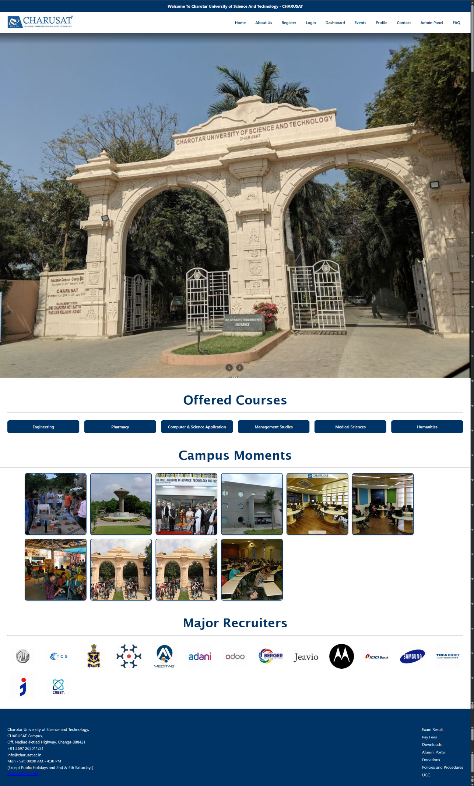

**CODE(about.html):**

<!DOCTYPE html>

<html lang="en">

<head>

  <meta charset="UTF-8">

  <meta name="viewport" content="width=device-width, initial-scale=1.0">

  <title>About CHARUSAT</title>

  <link rel="stylesheet" href="style.css">

</head>

<body>

  <!-- Announcement Bar -->

  <div class="announcement-bar">

    Welcome To Charotar University of Science And Technology - CHARUSAT

  </div>

  <!-- Header -->

  <header>

    <nav class="navbar">

      <div class="logo">

        <img src="logo.jpeg" alt="CHARUSAT Logo">

      </div>

      <ul class="nav-links">

        <li><a href="index.html">Home</a></li>

        <li><a href="about.html">About Us</a></li>

        <li><a href="register.html">Register</a></li>

        <li><a href="login.html">Login</a></li>

        <li><a href="dashboard.html">Dashboard</a></li>

        <li><a href="events.html">Events</a></li>

        <li><a href="profile.html">Profile</a></li>

        <li><a href="contact.html">Contact</a></li>

        <li><a href="admin.html">Admin Panel</a></li>

        <li><a href="faq.html">FAQ</a></li>

      </ul>

    </nav>

  </header>

  <!-- About Section -->

  <section class="about">

    <div class="about-content">

      <div class="about-text">

        <h1>About CHARUSAT</h1>

        <p>Charotar University of Science and Technology – CHARUSAT has been conceived by Shri Charotar Moti Sattavis Patidar Kelavani Mandal to put India on global education map by making Charotar – the Land of Sardar Patel, a Global Education Hub.</p>

        <p>Kelavani Mandal, established in 1994, is a non-profit premier trust of India that works with the aim to provide social service through education. The organization has a social lineage of more than 125 years. The parent organization, Shri Charotar Moti Sattavis Leuva Patidar Samaj– Matrusanstha- is known for the social revolution it brought about by initiating Mass Marriages in Patidar community on a massive scale.</p>

        <p>Kelavani Mandal has been established with the distinct objective of creating state-of-the-art educational facilities. The trust is a democratically managed institution known for its transparent functioning and integrity.</p>

        <p>The Kelavani Mandal is the sponsoring body of CHARUSAT. The development path of Kelavani Mandal was illuminated under the leadership of two former Presidents: Late Shri Chhotabhai Bhikhabhai Patel and Late Dr. K C Patel. Late Shri Chhotabhai Bhikhabhai Patel was an illustrious businessman and social leader based in Mumbai. This founder President of Kelavani Mandal always insisted on setting Global Standards. Late Dr. K C Patel, a renowned nuclear scientist and a prominent educationist of Gujarat, succeeded Shri Chhotabhai Bhikhabhai Patel, and dreamt of a university at Education Campus, Changa (ECC).</p>

        <br>

      </div>

    </div>

  </section>

  <!-- Footer -->

  <footer>

    <div class="footer-container">

      <div class="footer-contact">

        <h3>Contact</h3>

        <p>Charotar University of Science and Technology,<br>

        CHARUSAT Campus,<br>

        Off. Nadiad-Petlad Highway, Changa-388421<br>

        +91 2697 265011/21<br>

        info@charusat.ac.in<br>

        Mon - Sat: 09:00 AM - 4:30 PM<br>

        (Except Public Holidays and 2nd & 4th Saturdays)</p>

        <p><a href="#">How to Reach us?</a></p>

      </div>

      <div class="footer-links">

        <h3>Quick Links</h3>

        <ul>

          <li><a href="#">Exam Result</a></li>

          <li><a href="#">Pay Fees</a></li>

          <li><a href="#">Downloads</a></li>

          <li><a href="#">Alumni Portal</a></li>

          <li><a href="#">Donations</a></li>

          <li><a href="#">Policies and Procedures</a></li>

          <li><a href="#">UGC</a></li>

        </ul>

      </div>

    </div>

  </footer>

</body>

</html>

**OUTPUT(about.html):** 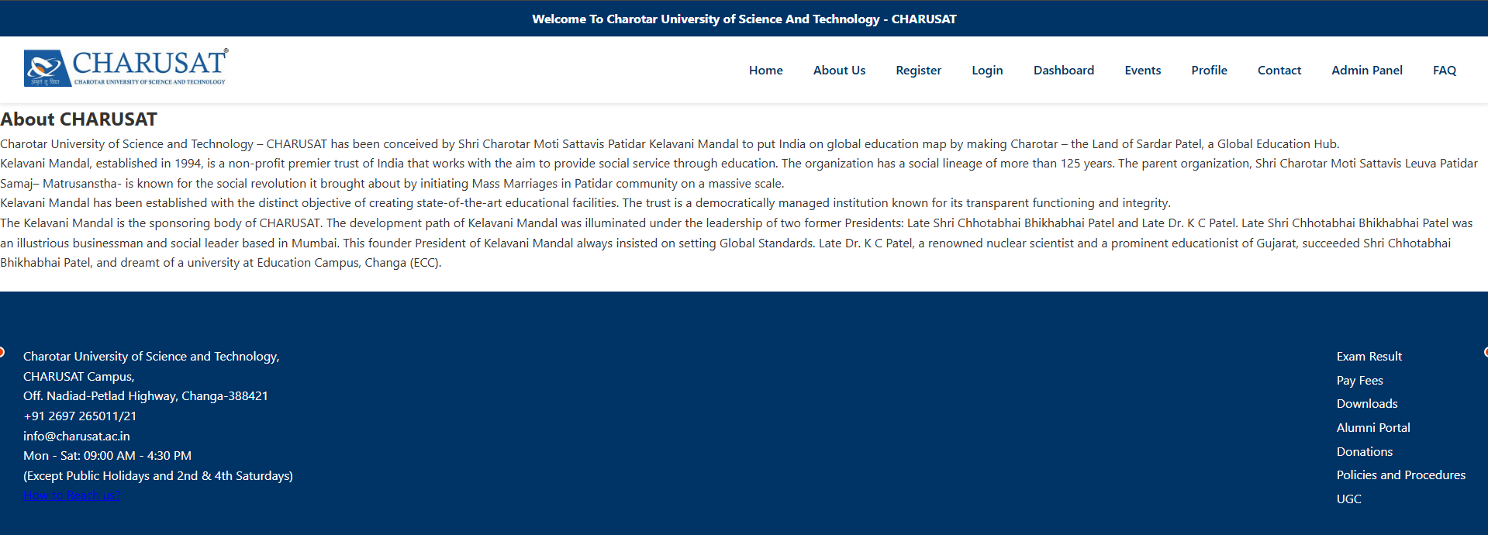

**CODE(register.html):**

<!DOCTYPE html>

<html lang="en">

<head>

  <meta charset="UTF-8">

  <meta name="viewport" content="width=device-width, initial-scale=1.0">

  <title>Register - CHARUSAT</title>

  <link rel="stylesheet" href="style.css">

</head>

<body>

  <!-- Announcement Bar -->

  <div class="announcement-bar">

    Welcome To Charotar University of Science And Technology - CHARUSAT

  </div>

  <!-- Header -->

  <header>

    <nav class="navbar">

      <div class="logo">

        <img src="logo.jpeg" alt="CHARUSAT Logo">

      </div>

      <ul class="nav-links">

        <li><a href="index.html">Home</a></li>

        <li><a href="about.html">About Us</a></li>

        <li><a href="register.html">Register</a></li>

        <li><a href="login.html">Login</a></li>

        <li><a href="dashboard.html">Dashboard</a></li>

        <li><a href="events.html">Events</a></li>

        <li><a href="profile.html">Profile</a></li>

        <li><a href="contact.html">Contact</a></li>

        <li><a href="admin.html">Admin Panel</a></li>

        <li><a href="faq.html">FAQ</a></li>

      </ul>

    </nav>

  </header>

<!-- Registration Form -->

  <section class="form-section">

    <h2>Student Registration</h2>

    <form class="form-container">

      <label for="fullname">Full Name</label>

      <input type="text" id="fullname" name="fullname" required>

      <label for="email">Email</label>

      <input type="email" id="email" name="email" required>

      <label for="phone">Phone</label>

      <input type="tel" id="phone" name="phone" required>

      <label for="dob">Date of Birth</label>

      <input type="date" id="dob" name="dob" required>

      <label for="course">Course</label>

      <select id="course" name="course" required>

        <option value="">-- Select Course --</option>

        <option value="engineering">Engineering</option>

        <option value="pharmacy">Pharmacy</option>

        <option value="csa">Computer & Science Application</option>

        <option value="management">Management Studies</option>

        <option value="sciences">Sciences</option>

        <option value="medical">Medical Sciences</option>

        <option value="humanities">Humanities</option>

      </select>

      <label for="password">Password</label>

      <input type="password" id="password" name="password" required>

      <label for="confirm_password">Confirm Password</label>

      <input type="password" id="confirm_password" name="confirm_password" required>

      <button type="submit">Register</button>

    </form>

  </section>

  <!-- Footer -->

  <footer>

    <div class="footer-container">

      <div class="footer-contact">

        <h3>Contact</h3>

        <p>Charotar University of Science and Technology,<br>

        CHARUSAT Campus,<br>

        Off. Nadiad-Petlad Highway, Changa-388421<br>

        +91 2697 265011/21<br>

        info@charusat.ac.in<br>

        Mon - Sat: 09:00 AM - 4:30 PM<br>

        (Except Public Holidays and 2nd & 4th Saturdays)</p>

        <p><a href="#">How to Reach us?</a></p>

      </div>

      <div class="footer-links">

        <h3>Quick Links</h3>

        <ul>

          <li><a href="#">Exam Result</a></li>

          <li><a href="qr.png">Pay Fees</a></li>

          <li><a href="#">Downloads</a></li>

          <li><a href="#">Alumni Portal</a></li>

          <li><a href="#">Donations</a></li>

          <li><a href="#">Policies and Procedures</a></li>

          <li><a href="#">UGC</a></li>

        </ul>

      </div>

    </div>

  </footer>

</body>

</html>

**OUTPUT(register.html):** 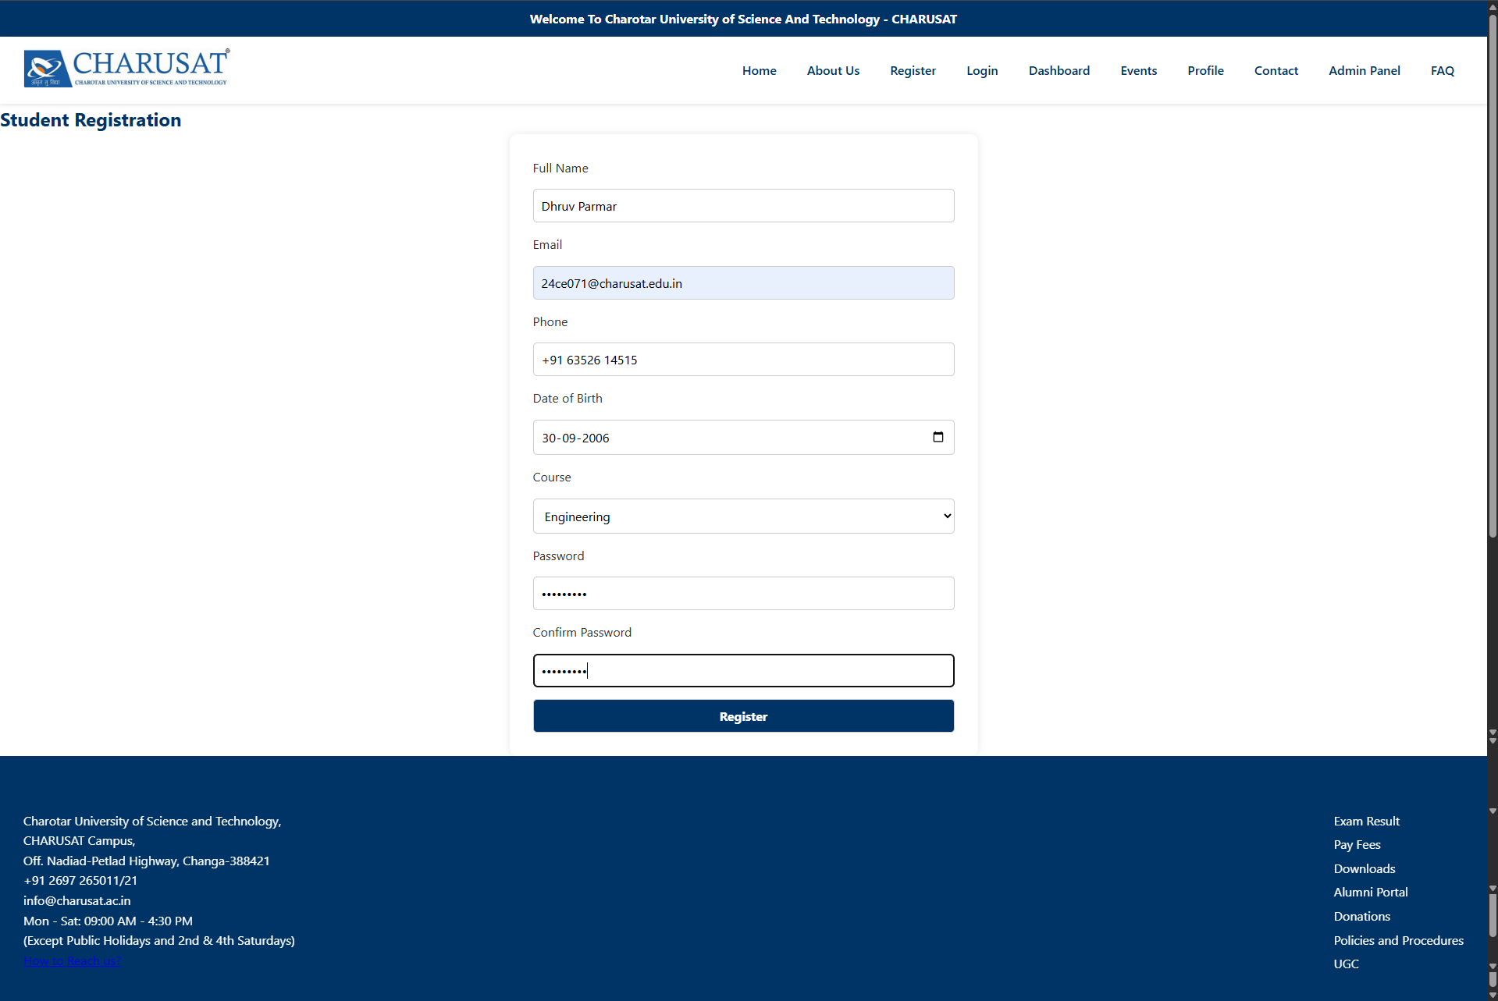

**CODE(login.html):** <!DOCTYPE html>

<html lang="en">

<head>

  <meta charset="UTF-8">

  <meta name="viewport" content="width=device-width, initial-scale=1.0">

  <title>Login - CHARUSAT</title>

  <link rel="stylesheet" href="style.css">

</head>

<body>

  <!-- Announcement Bar -->

  <div class="announcement-bar">

    Welcome To Charotar University of Science And Technology - CHARUSAT

  </div>

  <!-- Header -->

  <header>

    <nav class="navbar">

      <div class="logo">

        <img src="logo.jpeg" alt="CHARUSAT Logo">

      </div>

      <ul class="nav-links">

        <li><a href="index.html">Home</a></li>

        <li><a href="about.html">About Us</a></li>

        <li><a href="register.html">Register</a></li>

        <li><a href="login.html">Login</a></li>

        <li><a href="dashboard.html">Dashboard</a></li>

        <li><a href="events.html">Events</a></li>

        <li><a href="profile.html">Profile</a></li>

        <li><a href="contact.html">Contact</a></li>

        <li><a href="admin.html">Admin Panel</a></li>

        <li><a href="faq.html">FAQ</a></li>

      </ul>

    </nav>

  </header>

  <!-- Login Form -->

  <section class="form-section">

    <h2>Student Login</h2>

    <form class="form-container">

      <label for="email">Email</label>

      <input type="email" id="email" name="email" required>

      <label for="password">Password</label>

      <input type="password" id="password" name="password" required>

      <button type="submit">Login</button>

      <p class="form-link">Not registered? <a href="register.html">Create an account</a></p>

    </form>

  </section>

  <!-- Footer -->

  <footer>

    <div class="footer-container">

      <div class="footer-contact">

        <h3>Contact</h3>

        <p>Charotar University of Science and Technology,<br>

        CHARUSAT Campus,<br>

        Off. Nadiad-Petlad Highway, Changa-388421<br>

        +91 2697 265011/21<br>

        info@charusat.ac.in<br>

        Mon - Sat: 09:00 AM - 4:30 PM<br>

        (Except Public Holidays and 2nd & 4th Saturdays)</p>

        <p><a href="#">How to Reach us?</a></p>

      </div>

      <div class="footer-links">

        <h3>Quick Links</h3>

        <ul>

          <li><a href="#">Exam Result</a></li>

          <li><a href="qr.png">Pay Fees</a></li>

          <li><a href="#">Downloads</a></li>

          <li><a href="#">Alumni Portal</a></li>

          <li><a href="#">Donations</a></li>

          <li><a href="#">Policies and Procedures</a></li>

          <li><a href="#">UGC</a></li>

        </ul>

      </div>

    </div>

  </footer>

</body>

</html>

**OUTPUT(login.html):** 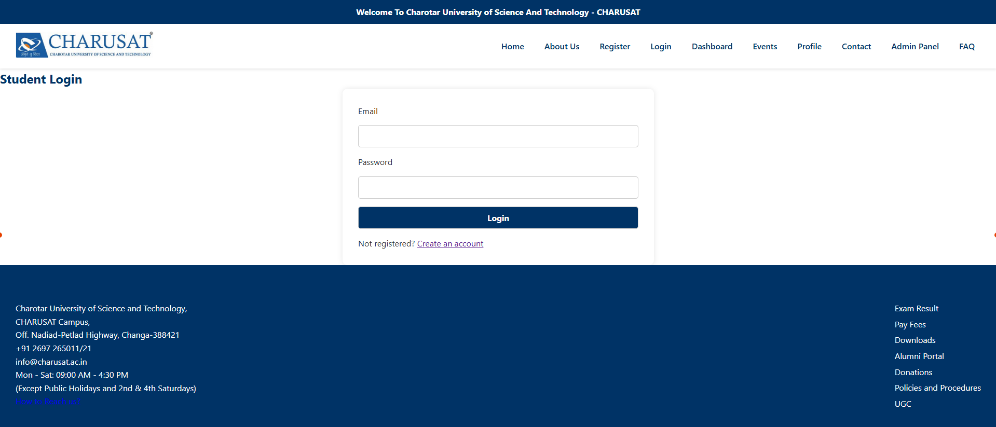

**CODE(dashboard.html):**

<!DOCTYPE html>

<html lang="en">

<head>

  <meta charset="UTF-8">

  <meta name="viewport" content="width=device-width, initial-scale=1.0">

  <title>Student Dashboard - CHARUSAT</title>

  <link rel="stylesheet" href="style.css">

</head>

<body>

  <!-- Announcement Bar -->

  <div class="announcement-bar">

    Welcome To Charotar University of Science And Technology - CHARUSAT </div>

  <!-- Header -->

  <header>

    <nav class="navbar">

      <div class="logo">

        <img src="logo.jpeg" alt="CHARUSAT Logo">

      </div>

      <ul class="nav-links">

        <li><a href="index.html">Home</a></li>

        <li><a href="about.html">About Us</a></li>

        <li><a href="register.html">Register</a></li>

        <li><a href="login.html">Login</a></li>

        <li><a href="dashboard.html">Dashboard</a></li>

        <li><a href="events.html">Events</a></li>

        <li><a href="profile.html">Profile</a></li>

        <li><a href="contact.html">Contact</a></li>

        <li><a href="admin.html">Admin Panel</a></li>

        <li><a href="faq.html">FAQ</a></li>

      </ul>

    </nav>

  </header>

  <!-- Dashboard Section -->

  <section class="dashboard">

    <h2>Welcome, Student</h2>

    <div class="dashboard-widgets">

      <div class="widget">

        <h3>Enrolled Courses</h3>

        <ul>

          <li>B.Tech Computer Engineering</li>

          <li>Mathematics II</li>

          <li>Digital Logic Design</li>

        </ul>

      </div>

      <div class="widget">

        <h3>Upcoming Events</h3>

        <ul>

          <li>SPOURAL 2025 – Aug 20</li>

          <li>Hackathon – Sept 5</li>

          <li>Quiz Competition – Sept 10</li>

        </ul>

      </div>

      <div class="widget">

        <h3>Quick Links</h3>

        <ul>

          <li><a href="profile.html">View Profile</a></li>

          <li><a href="events.html">Register for Events</a></li>

          <li><a href="contact.html">Contact Admin</a></li>

        </ul>

      </div>

    </div>

  </section>

  <!-- Footer -->

  <footer>

    <div class="footer-container">

      <div class="footer-contact">

        <h3>Contact</h3>

        <p>Charotar University of Science and Technology,<br>

        CHARUSAT Campus,<br>

        Off. Nadiad-Petlad Highway, Changa-388421<br>

        +91 2697 265011/21<br>

        info@charusat.ac.in<br>

        Mon - Sat: 09:00 AM - 4:30 PM<br>

        (Except Public Holidays and 2nd & 4th Saturdays)</p>

        <p><a href="#">How to Reach us?</a></p>

      </div>

      <div class="footer-links">

        <h3>Quick Links</h3>

        <ul>

          <li><a href="#">Exam Result</a></li>

          <li><a href="qr.png">Pay Fees</a></li>

          <li><a href="#">Downloads</a></li>

          <li><a href="#">Alumni Portal</a></li>

          <li><a href="#">Donations</a></li>

          <li><a href="#">Policies and Procedures</a></li>

          <li><a href="#">UGC</a></li>

        </ul>

      </div>

    </div>

  </footer>

</body>

</html>

**OUTPUT(dashboard.html):** 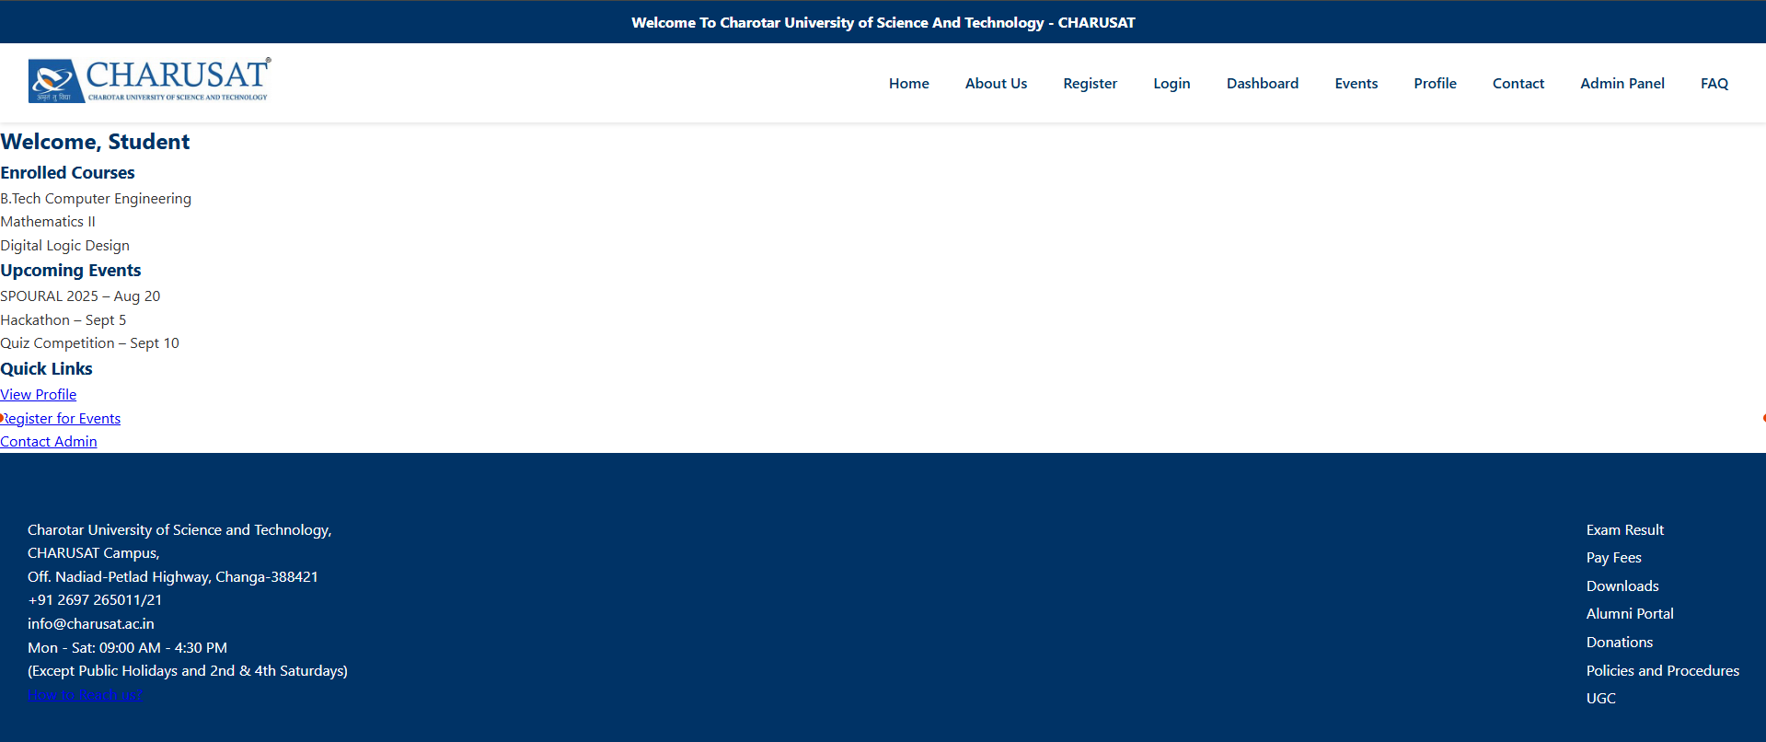

**CODE(events.html):**

<!DOCTYPE html>

<html lang="en">

<head>

  <meta charset="UTF-8">

  <meta name="viewport" content="width=device-width, initial-scale=1.0">

  <title>Events - CHARUSAT</title>

  <link rel="stylesheet" href="style.css">

</head>

<body>

  <!-- Announcement Bar -->

  <div class="announcement-bar">

    Welcome To Charotar University of Science And Technology - CHARUSAT

  </div>

  <!-- Header -->

  <header>

    <nav class="navbar">

      <div class="logo">

        <img src="logo.jpeg" alt="CHARUSAT Logo">

      </div>

      <ul class="nav-links">

        <li><a href="index.html">Home</a></li>

        <li><a href="about.html">About Us</a></li>

        <li><a href="register.html">Register</a></li>

        <li><a href="login.html">Login</a></li>

        <li><a href="dashboard.html">Dashboard</a></li>

        <li><a href="events.html">Events</a></li>

        <li><a href="profile.html">Profile</a></li>

        <li><a href="contact.html">Contact</a></li>

        <li><a href="admin.html">Admin Panel</a></li>

        <li><a href="faq.html">FAQ</a></li>

      </ul>

    </nav>

  </header>

  <!-- Events Section -->

  <section class="events-section">

    <h2>Event Registration</h2>

    <form class="form-container">

      <label for="studentName">Full Name</label>

      <input type="text" id="studentName" name="studentName" required>

      <label for="studentId">Student ID</label>

      <input type="text" id="studentId" name="studentId" required>

      <label for="event">Select Event</label>

      <select id="event" name="event" required>

        <option value="">-- Choose an Event --</option>

        <option value="spoural">SPOURAL 2025</option>

        <option value="football">Football Tournament</option>

        <option value="cultural">Cultural Events</option>

        <option value="chess">Chess Championship</option>

        <option value="hackathon">Hackathon</option>

        <option value="quiz">Quiz Competition</option>

        <option value="treasure">Treasure Hunt</option>

      </select>

      <button type="submit">Register</button>

    </form>

  </section>

  <!-- Footer -->

  <footer>

    <div class="footer-container">

      <div class="footer-contact">

        <h3>Contact</h3>

        <p>Charotar University of Science and Technology,<br>

        CHARUSAT Campus,<br>

        Off. Nadiad-Petlad Highway, Changa-388421<br>

        +91 2697 265011/21<br>

        info@charusat.ac.in<br>

        Mon - Sat: 09:00 AM - 4:30 PM<br>

        (Except Public Holidays and 2nd & 4th Saturdays)</p>

        <p><a href="#">How to Reach us?</a></p>

      </div>

      <div class="footer-links">

        <h3>Quick Links</h3>

        <ul>

          <li><a href="#">Exam Result</a></li>

          <li><a href="qr.png">Pay Fees</a></li>

          <li><a href="#">Downloads</a></li>

          <li><a href="#">Alumni Portal</a></li>

          <li><a href="#">Donations</a></li>

          <li><a href="#">Policies and Procedures</a></li>

          <li><a href="#">UGC</a></li>

        </ul>

      </div>

    </div>

  </footer>

</body>

</html>

**OUTPUT(events.html):** 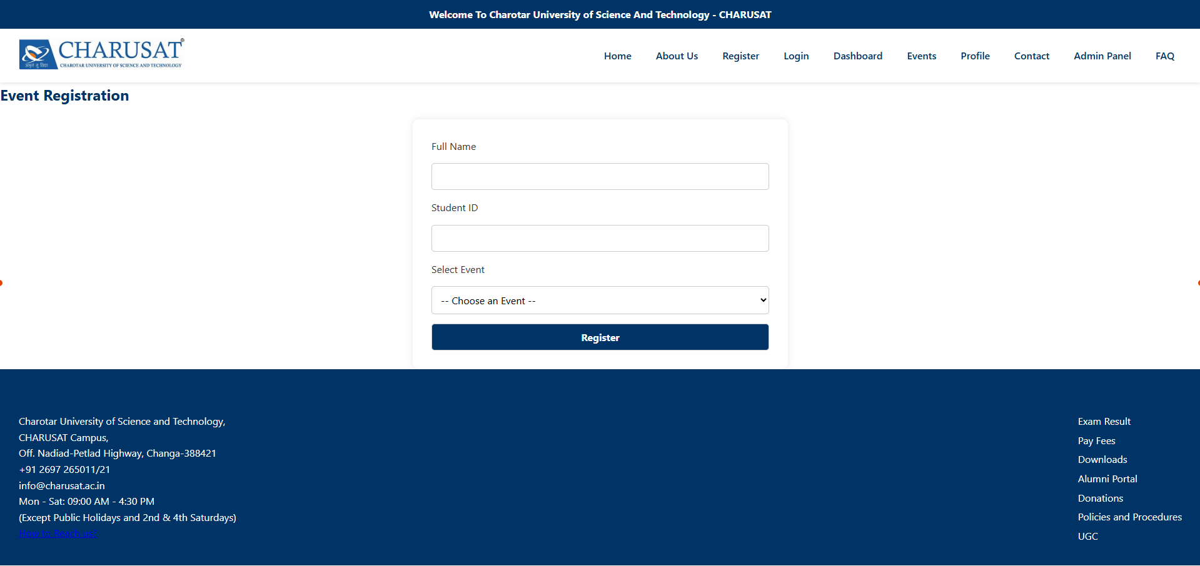

**CODE(profile.html):**

<!DOCTYPE html>

<html lang="en">

<head>

  <meta charset="UTF-8">

  <meta name="viewport" content="width=device-width, initial-scale=1.0">

  <title>Student Profile - CHARUSAT</title>

  <link rel="stylesheet" href="style.css">

</head>

<body>

  <!-- Announcement Bar -->

  <div class="announcement-bar">

    Welcome To Charotar University of Science And Technology - CHARUSAT

  </div>

  <!-- Header -->

  <header>

    <nav class="navbar">

      <div class="logo">

        <img src="logo.jpeg" alt="CHARUSAT Logo">

      </div>

      <ul class="nav-links">

        <li><a href="index.html">Home</a></li>

        <li><a href="about.html">About Us</a></li>

        <li><a href="register.html">Register</a></li>

        <li><a href="login.html">Login</a></li>

        <li><a href="dashboard.html">Dashboard</a></li>

        <li><a href="events.html">Events</a></li>

        <li><a href="profile.html">Profile</a></li>

        <li><a href="contact.html">Contact</a></li>

        <li><a href="admin.html">Admin Panel</a></li>

        <li><a href="faq.html">FAQ</a></li>

      </ul>

    </nav>

  </header>

  <!-- Profile Section -->

  <section class="profile-section">

    <h2>Student Profile</h2>

    <div class="profile-card">

      <img src="profile.jpg" alt="Student Photo" class="profile-pic">

      <div class="profile-details">

        <p><strong>Name:</strong> Dhruv Parmar</p>

        <p><strong>Student ID:</strong> 24CE071</p>

        <p><strong>Email:</strong> 24ce071@charuat.edu.in</p>

        <p><strong>Phone:</strong> +91 63526 14515</p>

        <p><strong>Department:</strong> CSPIT-Computer Engineering</p>

        <p><strong>Semester:</strong> 3</p>

        <p><strong>Enrolled Courses:</strong> DSA, Web Development Frameworks, OOPs in Java Programming.</p>

      </div>

    </div>

  </section>

  <!-- Footer -->

  <footer>

    <div class="footer-container">

      <div class="footer-contact">

        <h3>Contact</h3>

        <p>Charotar University of Science and Technology,<br>

        CHARUSAT Campus,<br>

        Off. Nadiad-Petlad Highway, Changa-388421<br>

        +91 2697 265011/21<br>

        info@charusat.ac.in<br>

        Mon - Sat: 09:00 AM - 4:30 PM<br>

        (Except Public Holidays and 2nd & 4th Saturdays)</p>

        <p><a href="#">How to Reach us?</a></p>

      </div>

      <div class="footer-links">

        <h3>Quick Links</h3>

        <ul>

          <li><a href="#">Exam Result</a></li>

          <li><a href="qr.png">Pay Fees</a></li>

          <li><a href="#">Downloads</a></li>

          <li><a href="#">Alumni Portal</a></li>

          <li><a href="#">Donations</a></li>

          <li><a href="#">Policies and Procedures</a></li>

          <li><a href="#">UGC</a></li>

        </ul>

      </div>

    </div>

  </footer>

</body>

</html>

**OUTPUT(profile.html):** 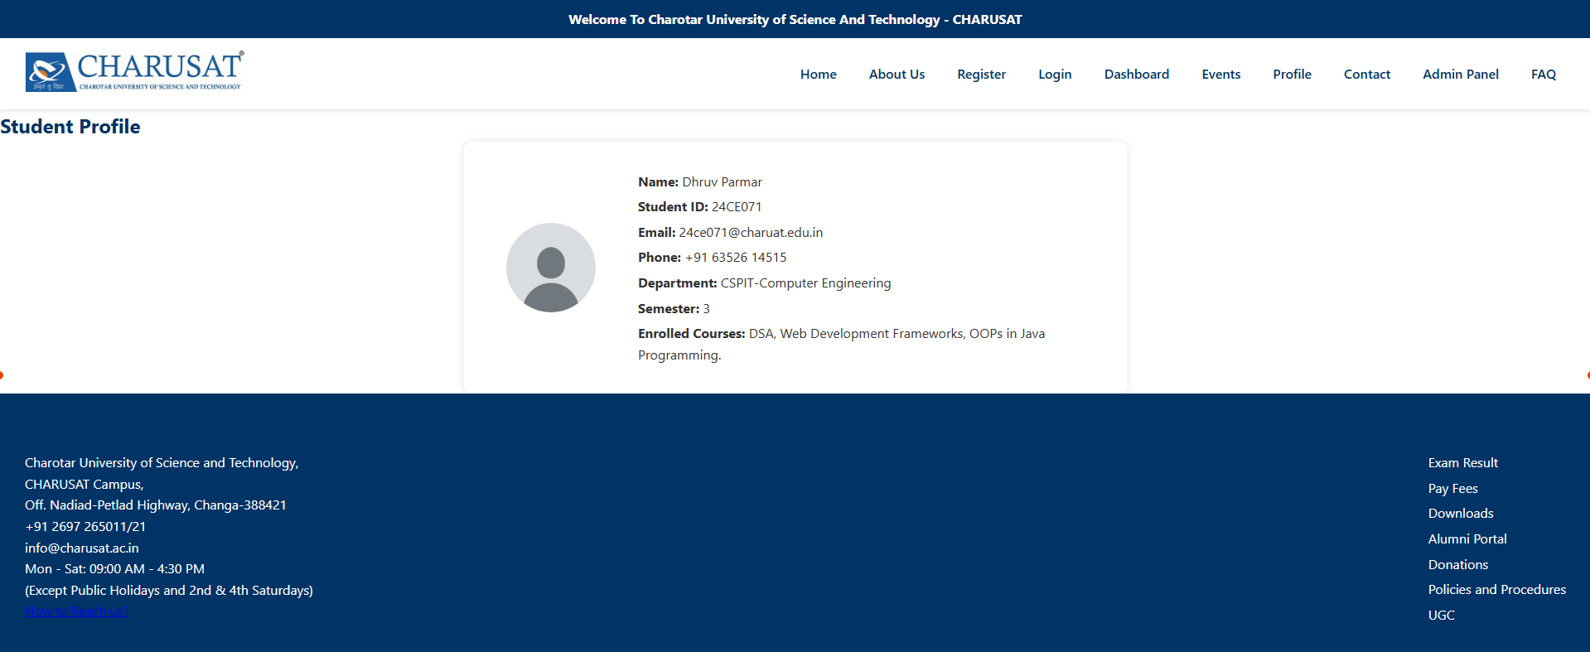

**CODE(contact.html):**

<!DOCTYPE html>

<html lang="en">

<head>

  <meta charset="UTF-8">

  <meta name="viewport" content="width=device-width, initial-scale=1.0">

  <title>Contact Us - CHARUSAT</title>

  <link rel="stylesheet" href="style.css">

</head>

<body>

  <!-- Announcement Bar -->

  <div class="announcement-bar">

    Welcome To Charotar University of Science And Technology - CHARUSAT

  </div>

  <!-- Header -->

  <header>

    <nav class="navbar">

      <div class="logo">

        <img src="logo.jpeg" alt="CHARUSAT Logo">

      </div>

      <ul class="nav-links">

        <li><a href="index.html">Home</a></li>

        <li><a href="about.html">About Us</a></li>

        <li><a href="register.html">Register</a></li>

        <li><a href="login.html">Login</a></li>

        <li><a href="dashboard.html">Dashboard</a></li>

        <li><a href="events.html">Events</a></li>

        <li><a href="profile.html">Profile</a></li>

        <li><a href="contact.html">Contact</a></li>

        <li><a href="admin.html">Admin Panel</a></li>

        <li><a href="faq.html">FAQ</a></li>

      </ul>

    </nav>

  </header>

  <!-- Contact Section -->

  <section class="contact-section">

    <h2>Contact Us</h2>

    <div class="contact-content">

      <div class="contact-details">

        <p><strong>Address:</strong><br>

          Charotar University of Science and Technology,<br>

          CHARUSAT Campus,<br>

          Off. Nadiad-Petlad Highway,<br>

          Changa-388421, Gujarat, India

        </p>

        <p><strong>Phone:</strong> +91 2697 265011/21</p>

        <p><strong>Email:</strong> info@charusat.ac.in</p>

        <p><strong>Working Hours:</strong> Mon - Sat: 09:00 AM - 4:30 PM<br>

        (Except Public Holidays and 2nd & 4th Saturdays)</p>

        <p><a href="#">How to Reach us?</a></p>

      </div>

    </div>

  </section>

  <!-- Footer -->

  <footer>

    <div class="footer-container">

      <div class="footer-contact">

        <h3>Contact</h3>

        <p>Charotar University of Science and Technology,<br>

        CHARUSAT Campus,<br>

        Off. Nadiad-Petlad Highway, Changa-388421<br>

        +91 2697 265011/21<br>

        info@charusat.ac.in<br>

        Mon - Sat: 09:00 AM - 4:30 PM<br>

        (Except Public Holidays and 2nd & 4th Saturdays)</p>

        <p><a href="#">How to Reach us?</a></p>

      </div>

      <div class="footer-links">

        <h3>Quick Links</h3>

        <ul>

          <li><a href="#">Exam Result</a></li>

          <li><a href="qr.png">Pay Fees</a></li>

          <li><a href="#">Downloads</a></li>

          <li><a href="#">Alumni Portal</a></li>

          <li><a href="#">Donations</a></li>

          <li><a href="#">Policies and Procedures</a></li>

          <li><a href="#">UGC</a></li>

        </ul>

      </div>

    </div>

  </footer>

</body>

</html>

**OUTPUT(contact.html):** 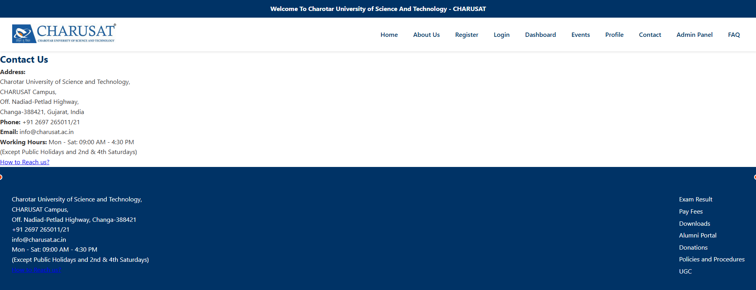

**CODE(admin.html):**

<!DOCTYPE html>

<html lang="en">

<head>

  <meta charset="UTF-8">

  <meta name="viewport" content="width=device-width, initial-scale=1.0">

  <title>Admin Panel - CHARUSAT</title>

  <link rel="stylesheet" href="style.css">

</head>

<body>

  <!-- Announcement Bar -->

  <div class="announcement-bar">

    Welcome To Charotar University of Science And Technology - CHARUSAT

  </div>

  <!-- Header -->

  <header>

    <nav class="navbar">

      <div class="logo">

        <img src="logo.jpeg" alt="CHARUSAT Logo">

      </div>

      <ul class="nav-links">

        <li><a href="index.html">Home</a></li>

        <li><a href="about.html">About Us</a></li>

        <li><a href="register.html">Register</a></li>

        <li><a href="login.html">Login</a></li>

        <li><a href="dashboard.html">Dashboard</a></li>

        <li><a href="events.html">Events</a></li>

        <li><a href="profile.html">Profile</a></li>

        <li><a href="contact.html">Contact</a></li>

        <li><a href="admin.html">Admin Panel</a></li>

        <li><a href="faq.html">FAQ</a></li>

      </ul>

    </nav>

  </header>

<!-- Admin Panel Section -->

  <section class="admin-panel">

    <h2>Admin Control Panel</h2>

    <div class="admin-controls">

      <form class="form-container">

        <h3>Manage Batches</h3>

        <label for="batchName">Add New Batch</label>

        <input type="text" id="batchName" name="batchName" placeholder="e.g. 2025-29" required>

        <button type="submit">Add Batch</button>

        <h3>Student ID Control</h3>

        <label for="studentId">Enter Student ID</label>

        <input type="text" id="studentId" name="studentId" placeholder="e.g. 21CEU123" required>

        <label for="action">Action</label>

        <select id="action" name="action" required>

          <option value="">-- Select Action --</option>

          <option value="activate">Activate</option>

          <option value="deactivate">Deactivate</option>

          <option value="delete">Delete</option>

        </select>

        <button type="submit">Submit</button>

      </form>

    </div>

  </section>

  <!-- Footer -->

  <footer>

    <div class="footer-container">

      <div class="footer-contact">

        <h3>Contact</h3>

        <p>Charotar University of Science and Technology,<br>

        CHARUSAT Campus,<br>

        Off. Nadiad-Petlad Highway, Changa-388421<br>

        +91 2697 265011/21<br>

        info@charusat.ac.in<br>

        Mon - Sat: 09:00 AM - 4:30 PM<br>

        (Except Public Holidays and 2nd & 4th Saturdays)</p>

        <p><a href="#">How to Reach us?</a></p>

      </div>

      <div class="footer-links">

        <h3>Quick Links</h3>

        <ul>

          <li><a href="#">Exam Result</a></li>

          <li><a href="qr.png">Pay Fees</a></li>

          <li><a href="#">Downloads</a></li>

          <li><a href="#">Alumni Portal</a></li>

          <li><a href="#">Donations</a></li>

          <li><a href="#">Policies and Procedures</a></li>

          <li><a href="#">UGC</a></li>

        </ul>

      </div>

    </div>

  </footer>

</body>

</html>

**OUTPUT(admin.html):** 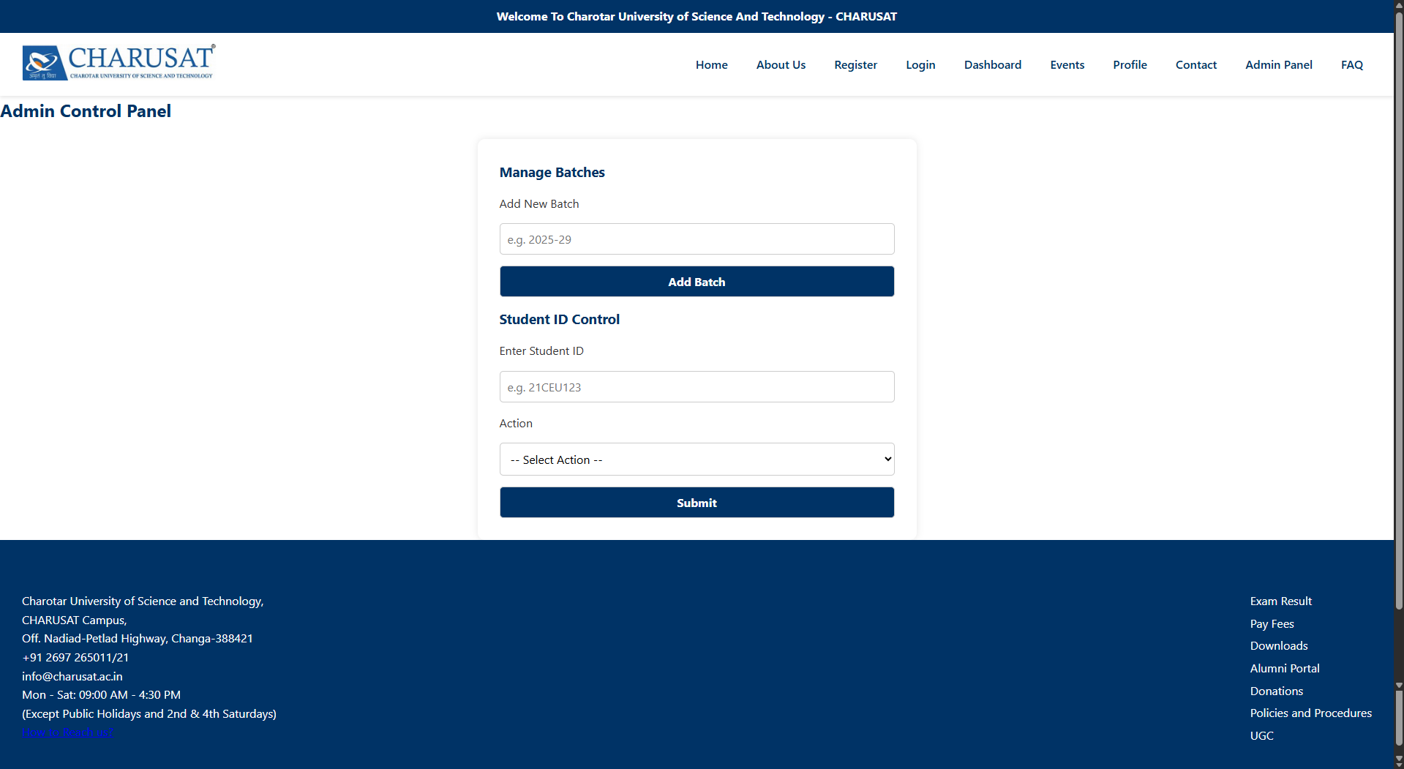

**CODE(faq.html):**

<!DOCTYPE html>

<html lang="en">

<head>

  <meta charset="UTF-8">

  <meta name="viewport" content="width=device-width, initial-scale=1.0">

  <title>FAQ - CHARUSAT</title>

  <link rel="stylesheet" href="style.css">

</head>

<body>

  <!-- Announcement Bar -->

  <div class="announcement-bar">

    Welcome To Charotar University of Science And Technology - CHARUSAT

  </div>

  <!-- Header -->

  <header>

    <nav class="navbar">

      <div class="logo">

        <img src="logo.jpeg" alt="CHARUSAT Logo">

      </div>

      <ul class="nav-links">

        <li><a href="index.html">Home</a></li>

        <li><a href="about.html">About Us</a></li>

        <li><a href="register.html">Register</a></li>

        <li><a href="login.html">Login</a></li>

        <li><a href="dashboard.html">Dashboard</a></li>

        <li><a href="events.html">Events</a></li>

        <li><a href="profile.html">Profile</a></li>

        <li><a href="contact.html">Contact</a></li>

        <li><a href="admin.html">Admin Panel</a></li>

        <li><a href="faq.html">FAQ</a></li>

      </ul>

    </nav>

  </header>

  <!-- FAQ Section -->

  <section class="faq-section">

    <h2>Frequently Asked Questions</h2>

    <div class="faq-item">

      <h3>1. How can I pay my fees?</h3>

      <p>You can pay your fees online through the <a href="qr.png">Pay Fees</a> portal. For more assistance, visit the <a href="contact.html">Contact Us</a> page.</p>

    </div>

    <div class="faq-item">

      <h3>2. Where can I find my exam results?</h3>

      <p>Exam results are published on the <a href="#">Exam Result</a> section regularly.</p>

    </div>

    <div class="faq-item">

      <h3>3. How do I register for events?</h3>

      <p>You can register for university events on the <a href="events.html">Events</a> page.</p>

    </div>

    <div class="faq-item">

      <h3>4. What should I do if I forget my login credentials?</h3>

      <p>Please contact the administration via the <a href="contact.html">Contact</a> page for support with login issues.</p>

    </div>

    <div class="faq-item">

      <h3>5. How to reach CHARUSAT campus?</h3>

      <p>Refer to the directions provided in the <a href="contact.html">How to Reach us?</a> section on the contact page.</p>

    </div>

  </section>

  <!-- Footer -->

  <footer>

    <div class="footer-container">

      <div class="footer-contact">

        <h3>Contact</h3>

        <p>Charotar University of Science and Technology,<br>

        CHARUSAT Campus,<br>

        Off. Nadiad-Petlad Highway, Changa-388421<br>

        +91 2697 265011/21<br>

        info@charusat.ac.in<br>

        Mon - Sat: 09:00 AM - 4:30 PM<br>

        (Except Public Holidays and 2nd & 4th Saturdays)</p>

        <p><a href="#">How to Reach us?</a></p>

      </div>

      <div class="footer-links">

        <h3>Quick Links</h3>

        <ul>

          <li><a href="#">Exam Result</a></li>

          <li><a href="qr.png">Pay Fees</a></li>

          <li><a href="#">Downloads</a></li>

          <li><a href="#">Alumni Portal</a></li>

          <li><a href="#">Donations</a></li>

          <li><a href="#">Policies and Procedures</a></li>

          <li><a href="#">UGC</a></li>

        </ul>

      </div>

    </div>

  </footer>

</body>

</html>

**OUTPUT(faq.html):** 